A project Report On

**Play Zone Web App**

Name: Sawant Nikhilraj Ashok

Type of Project : Web Technology

Technology : HTML5, CSS3, BOOTSTRAP5 & JAVASCRIPT

Date Of Submission: 15-10-2025

**Table Of Contents:**

1. Introduction
2. Project Objectives
3. Technologies Used
4. Features
5. Implementation
6. User Interface Design
7. Testing
8. Future Improvements
9. Conclusion

## 1. Introduction

**Play Zone** is a web-based gaming platform that offers multiple mini-games in a single interface. It provides an engaging user experience with features like a loading screen, dashboard analytics, and progress tracking. Each game records play count and total time using local storage. The project is developed using **HTML, CSS, JavaScript, and Bootstrap** for a responsive and interactive design. Overall, it combines fun and functionality in a simple, user-friendly gaming environment.

## 2. Project Objectives

* To develop a **web-based gaming platform** that hosts multiple mini-games in one place.
* To implement a **dashboard system** that tracks game statistics like plays and total time.
* To create a **loading screen and progress indicators** for better user experience.
* To enhance **user engagement** by offering visual effects, dark/light mode, and seamless game transitions.
* To include a **search feature** for quick access to games.
* To implement **Liked Games** functionality for users to save their favorite games.

## 3. Technologies

* **HTML5**: For structuring the content of the web application.
* **CSS3**: For styling, animations, and layout design, including Bootstrap for responsiveness.
* **JavaScript**: For interactive functionalities like game logic, search, liked games, and dashboard updates.
* **Bootstrap**: A CSS framework to ensure responsive design across devices.
* **Font Awesome**: For icons used throughout the application.
* **EmailJS**: For sending emails directly from the application without server-side code.

## 4. Features

* **Search Functionality**: Users can search for games by name to quickly find and play their favorite games.
* **Game Cards**: Displaying available games with images, videos, and interactive play buttons.
* **Liked Games Section**: Users can like games and view them later in a separate drawer.
* **Curated Collections**: Highlighting most played games and trending games on the dashboard.
* **Dashboard Stats**: Tracking plays, total time played, and session details for each game.
* **Contact Section**: Allowing users to send emails using EmailJS to share feedback or app details.

## 5. Implementation

### Structure

The project is divided into several sections:

* **Navbar**: Provides navigation links to games, liked section, profile drawer, and dashboard.
* **Hero / Background Section**: Contains a video with a Play Button for games.
* **Game List**: Displays various games in card format with images, videos, and play and like buttons.
* **Collections Section**: Highlights most played games and trending games.
* **Upcoming Section**: Shows upcoming games or features for users to explore.
* **About Section**: Provides information about the application and its purpose.
* **Contact Section**: Allows users to send emails via EmailJS for feedback or app sharing.
* **Liked Games Drawer**: Displays games liked by the user in a separate drawer.
* **Profile Drawer with Dashboard**: Shows user stats, game play history, and total time spent on games.

## 6. Output Screens

HOME

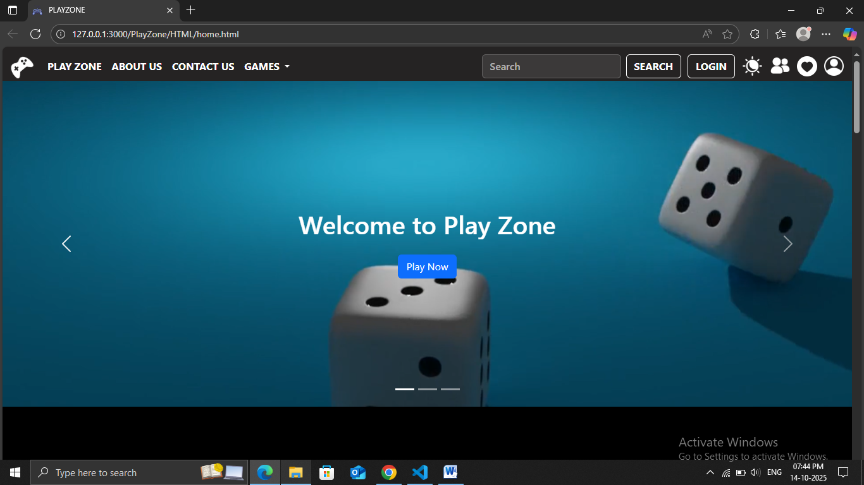

GAMES

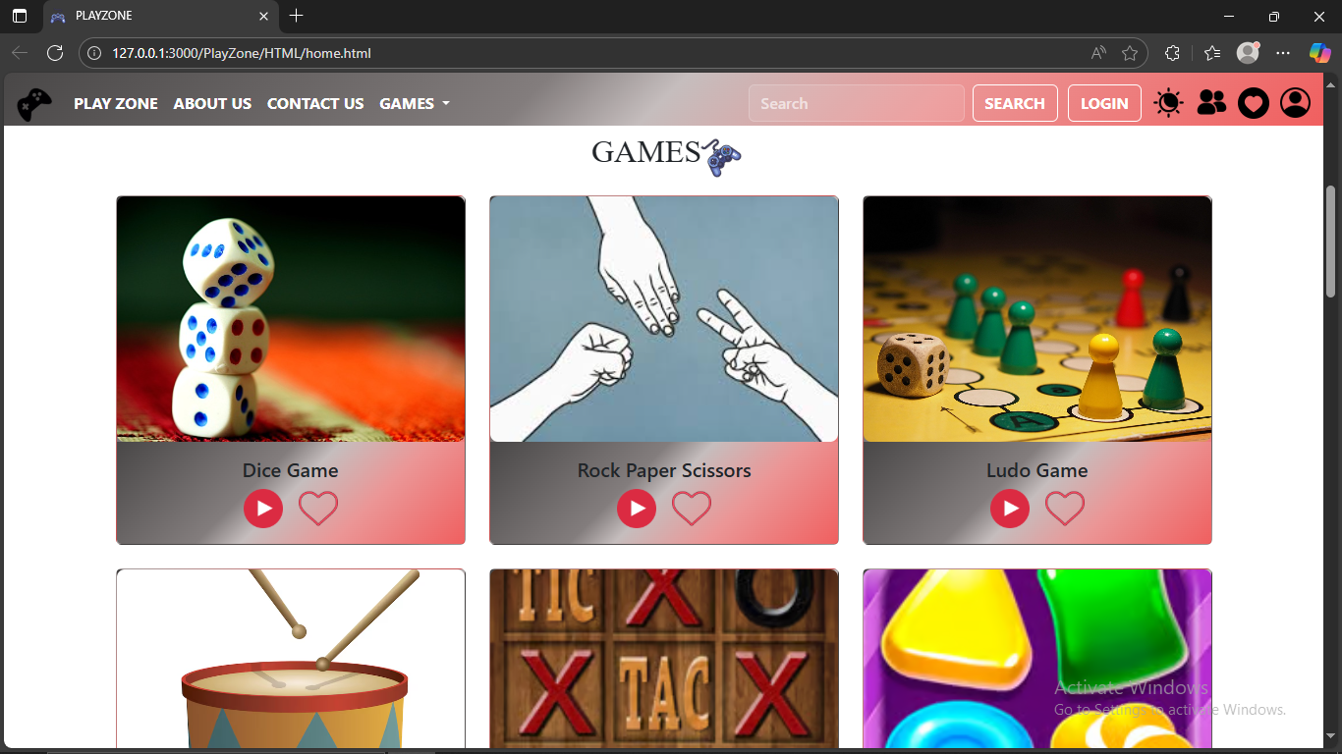

## MOST LOVED GAMES

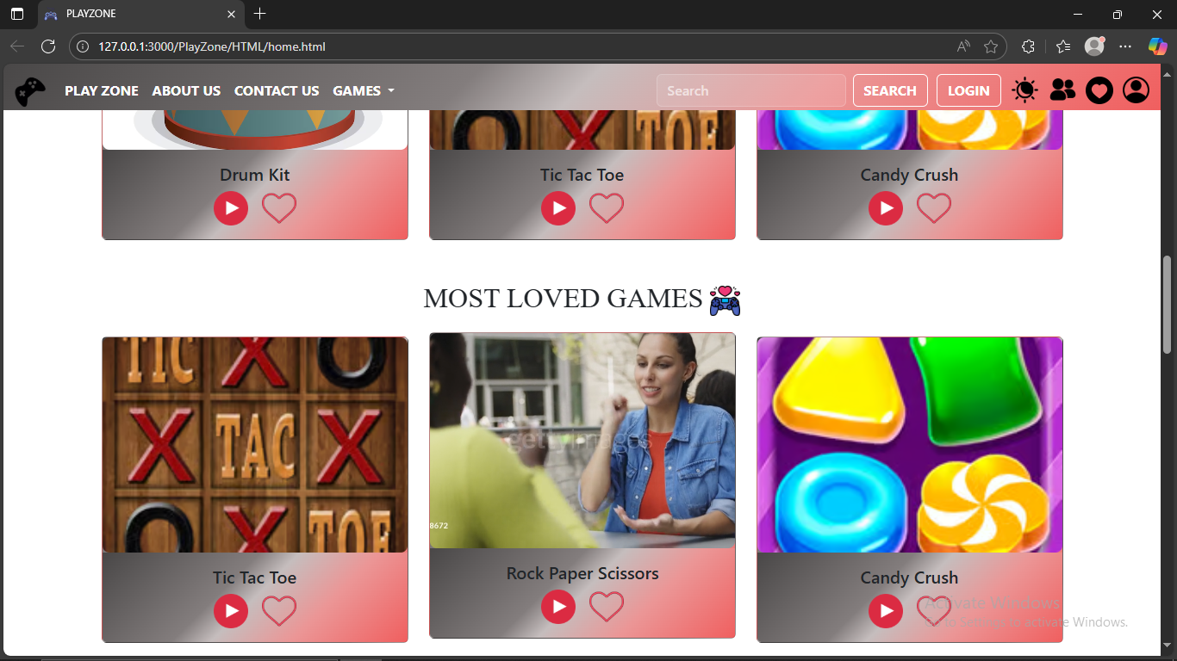

## UPCOMING GAMES

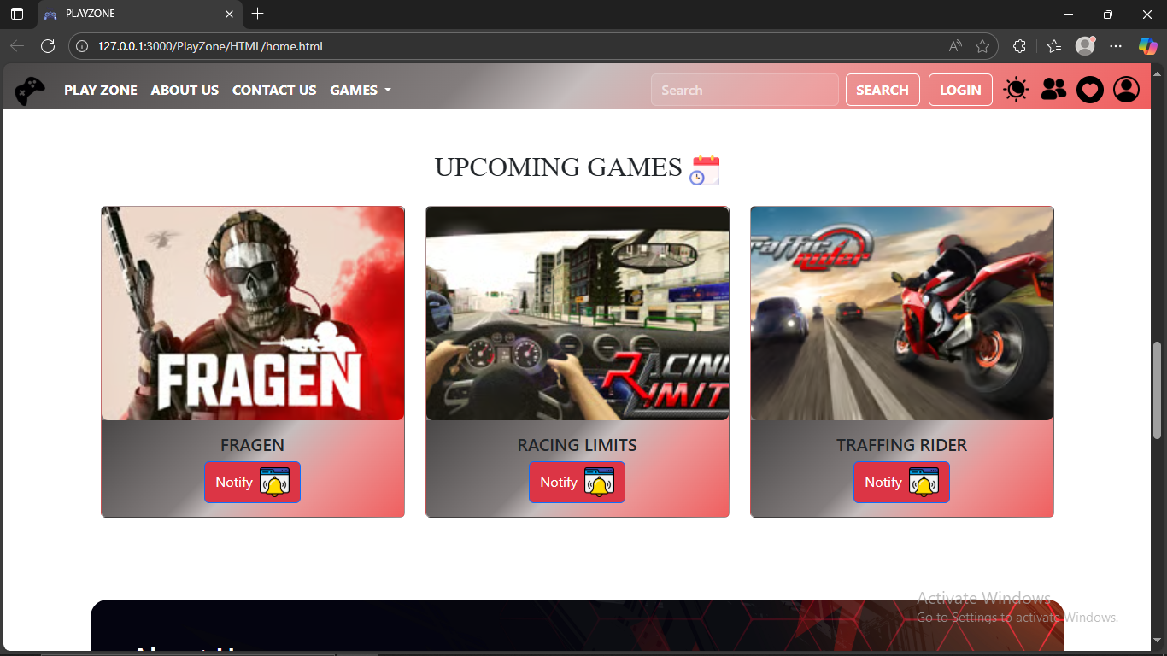

About Us

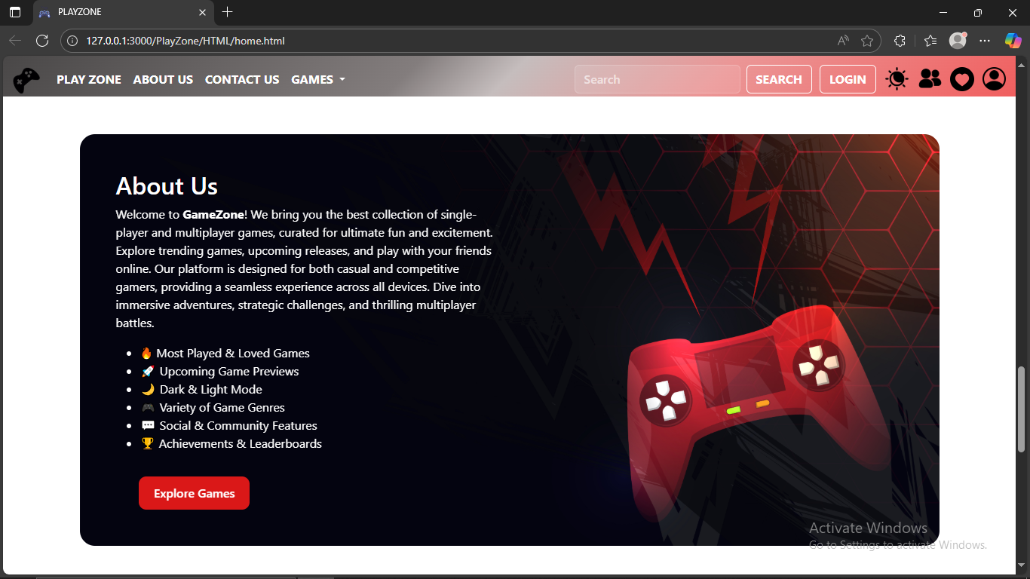

Contact Us

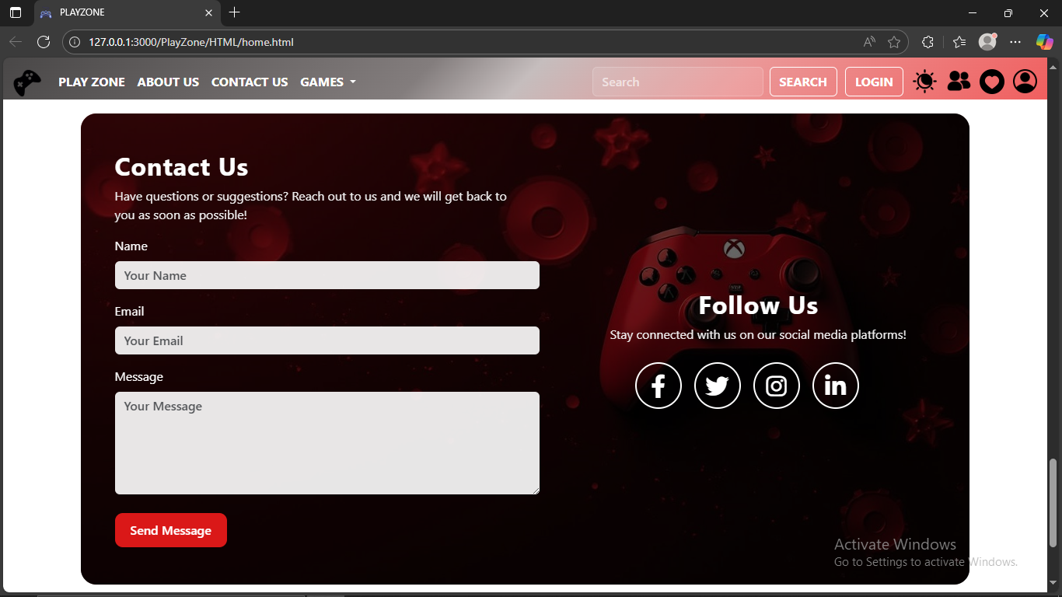

Footer

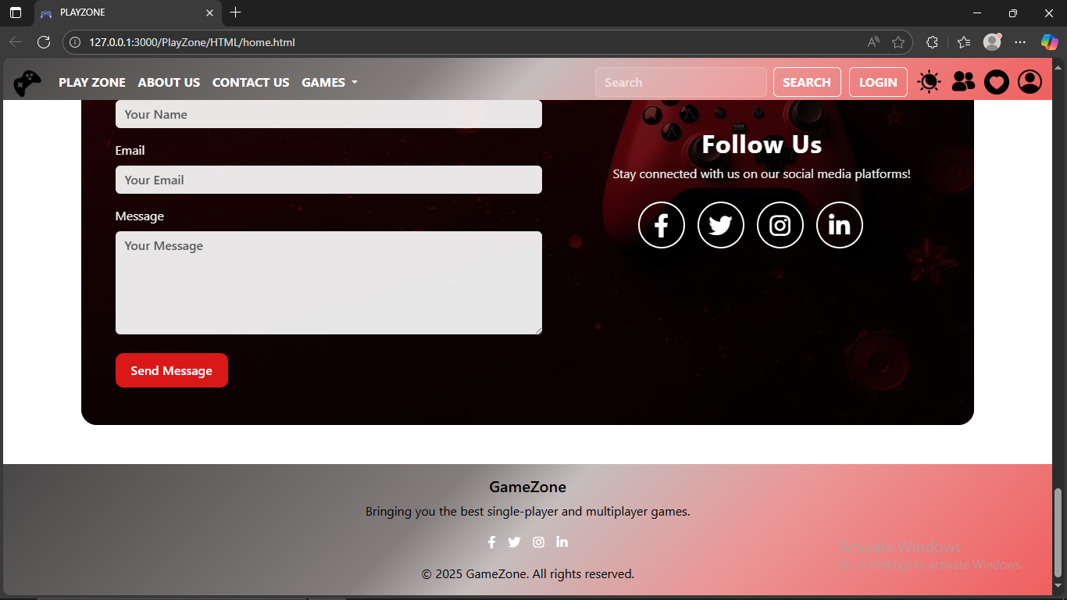

SINGLE/MULTI PLAYER GAMES

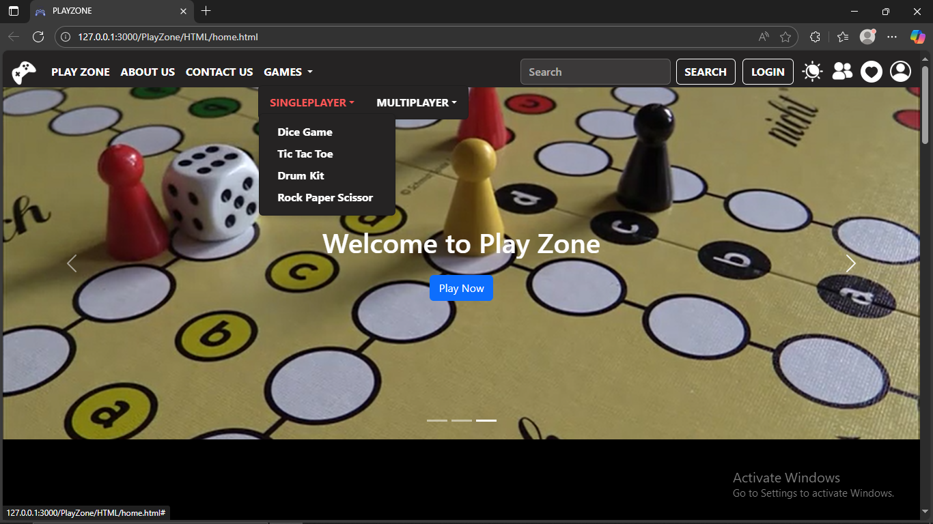

LOGIN SCREEN

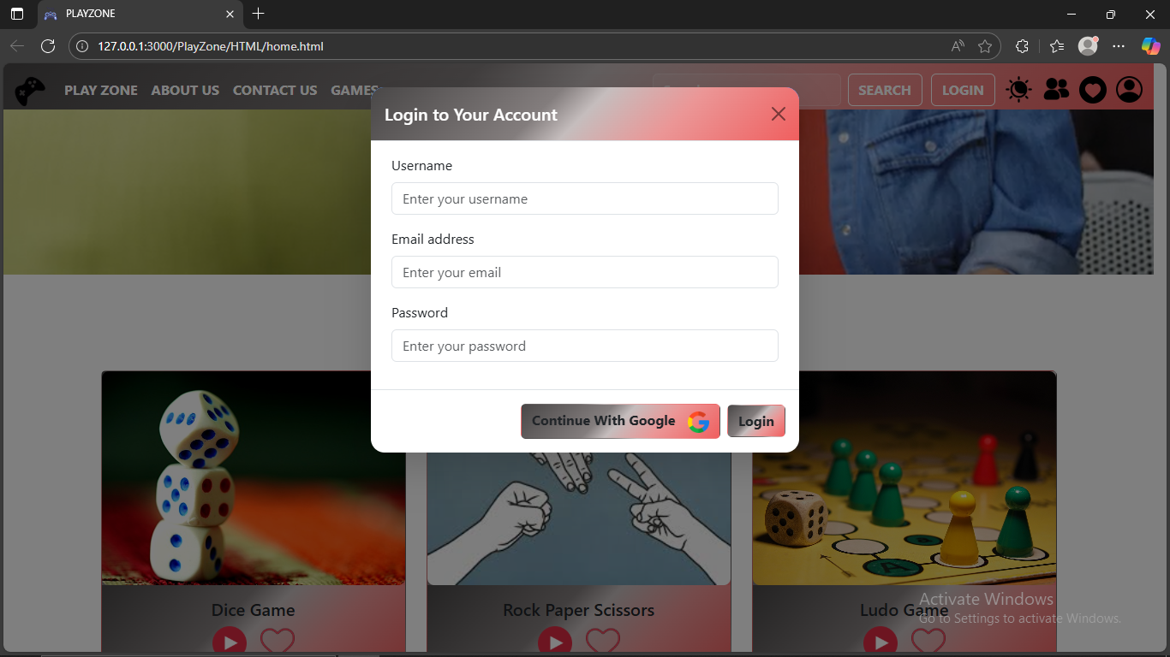

WELCOME SCREEN

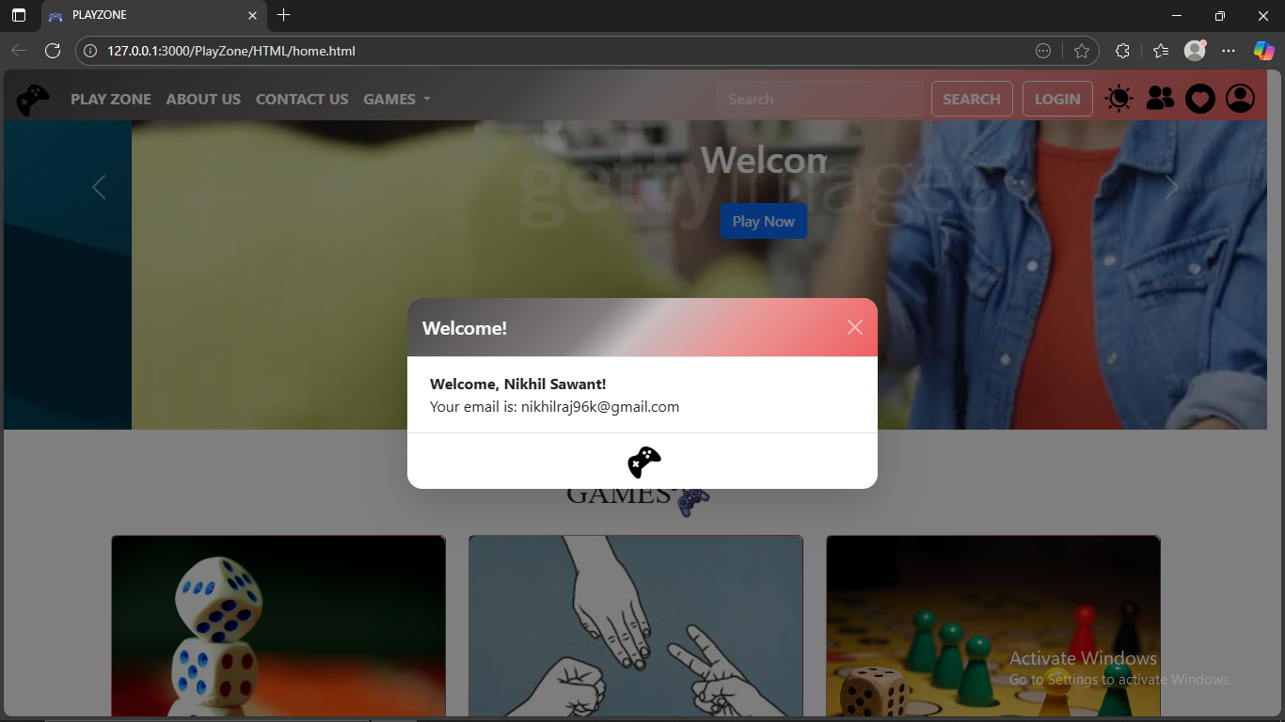

LIKED DRAWER

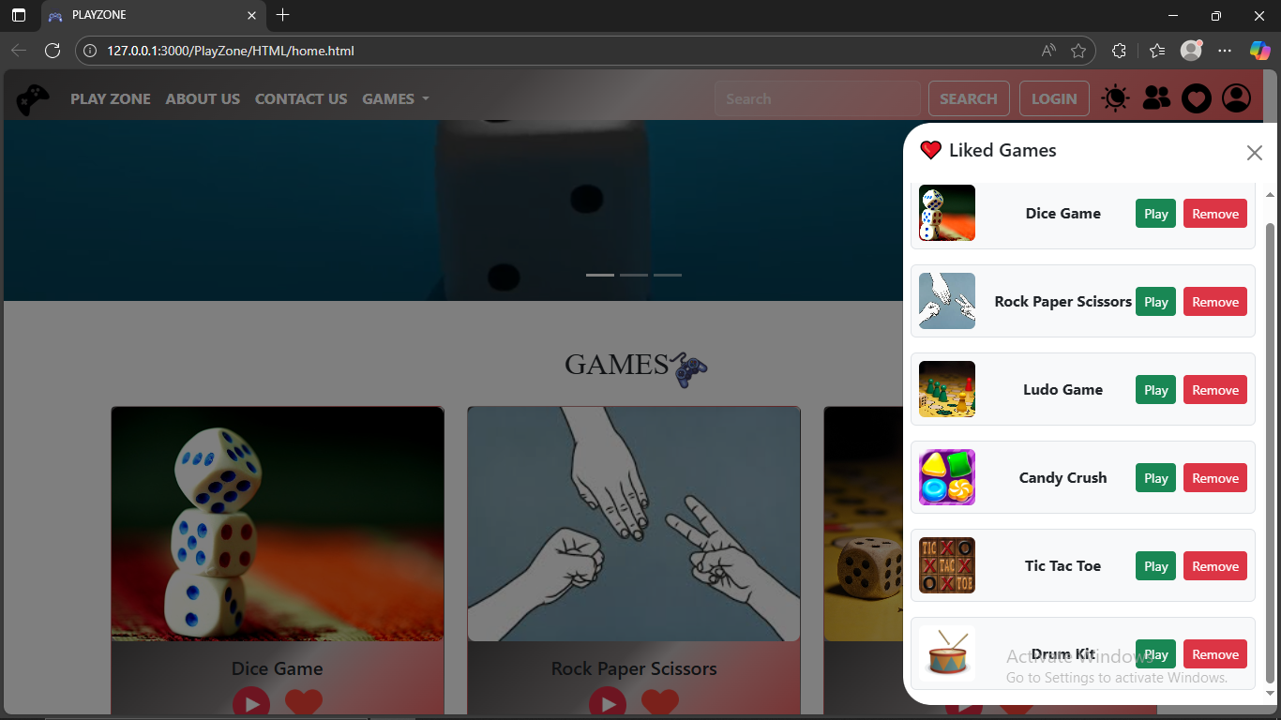

PROFILE DRAWER

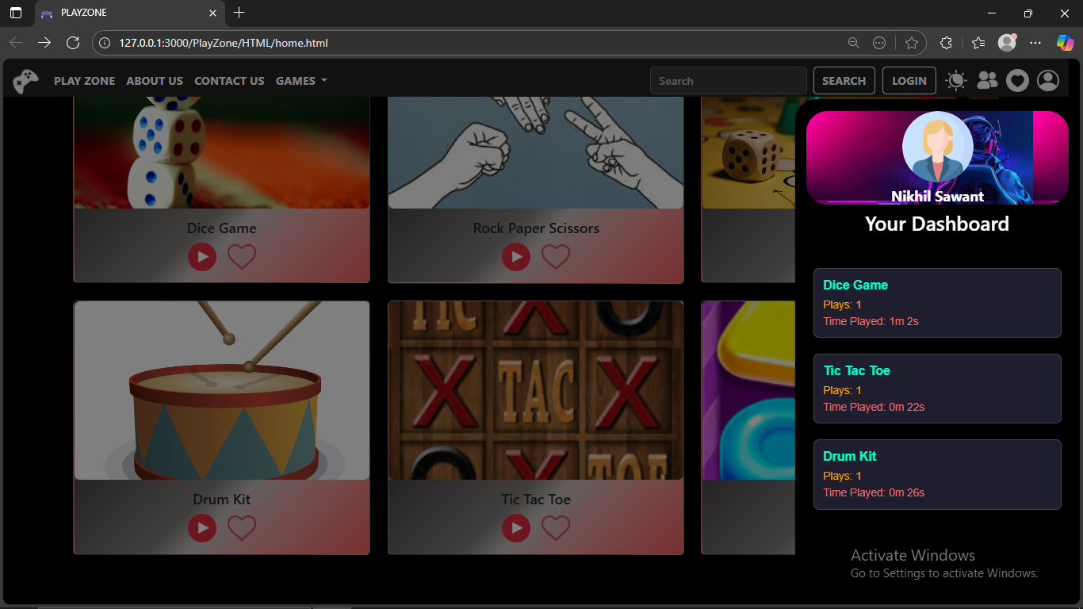

LOADING SCREEN

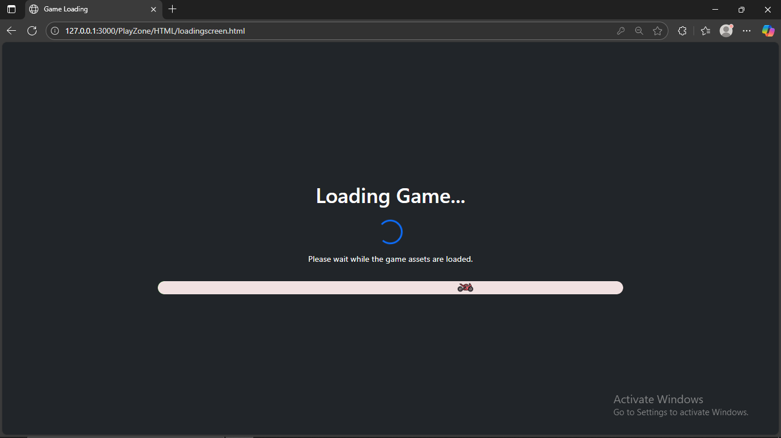

DICE GAME

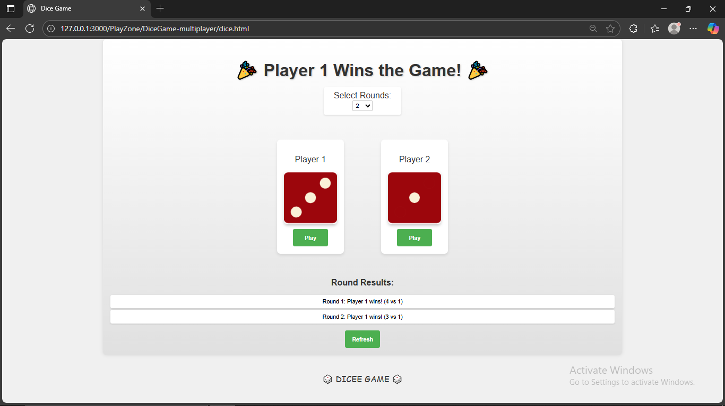

TIC TAC TOE GAME

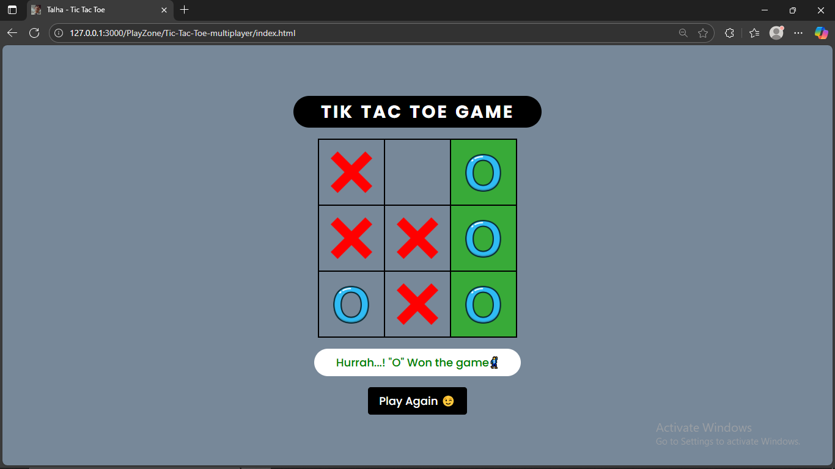

ROCK PAPER SCISSORS GAME

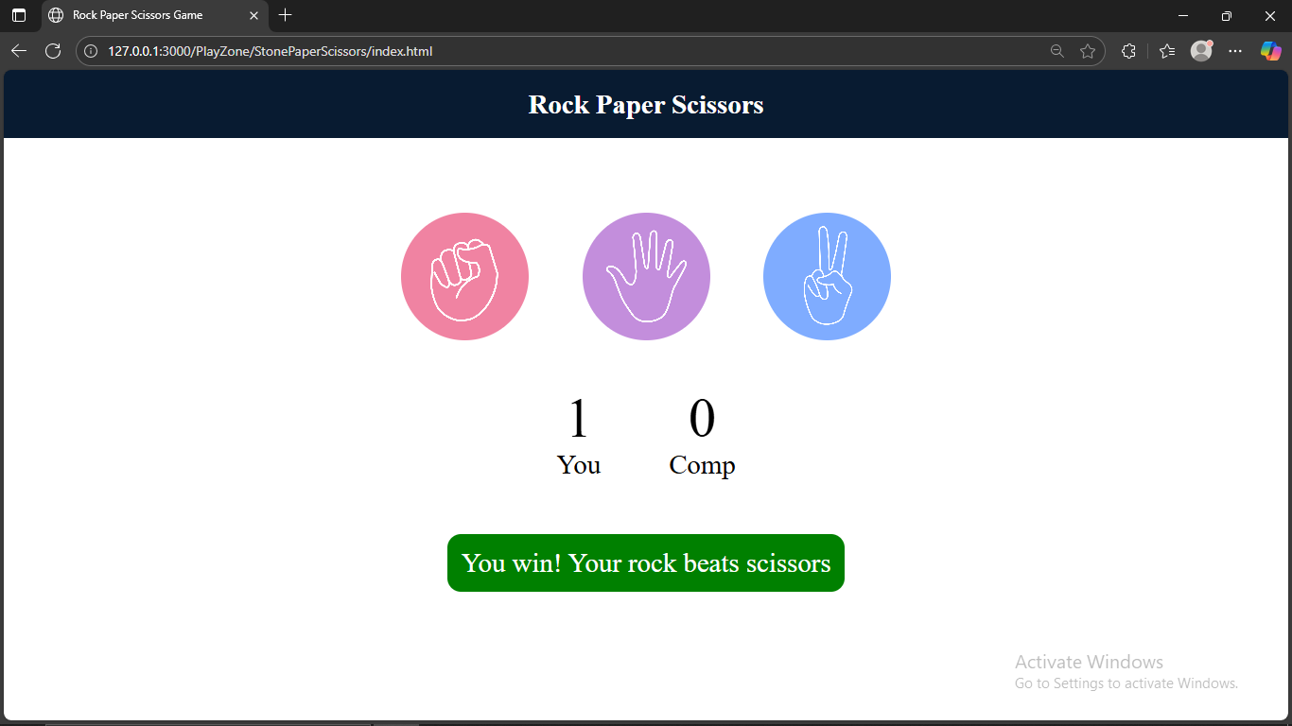

DRUM IT GAME

## 

EMAILJS

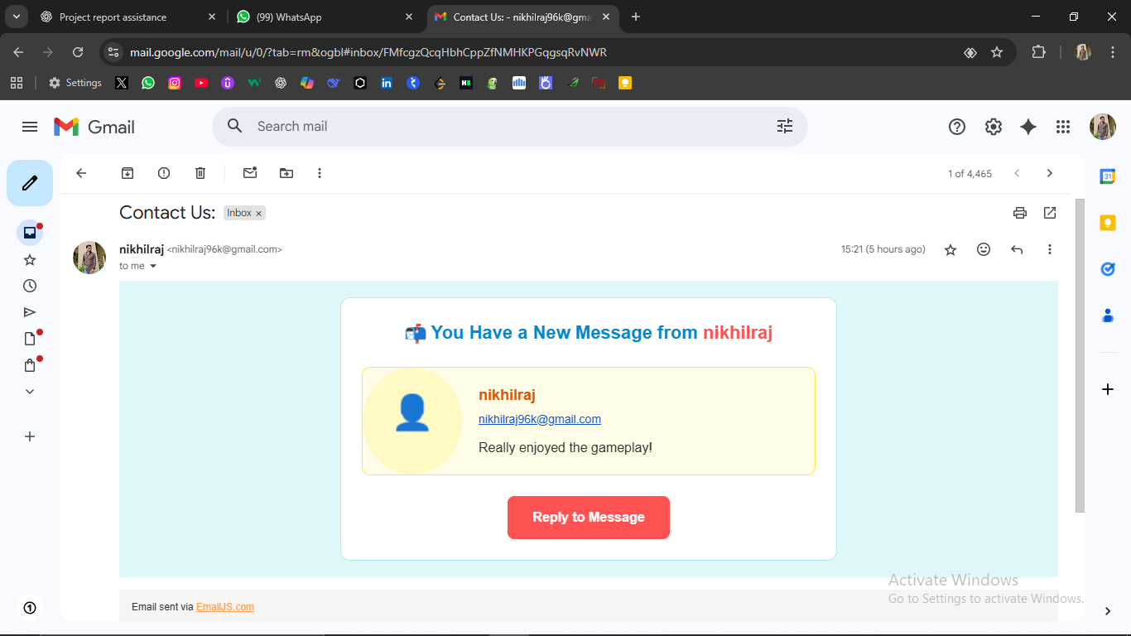

## 8. Future Improvements

* **Multiplayer Online Mode**: Enable players to compete online in real-time instead of only local turns.
* **Enhanced Search & Filters**: Add advanced search filters to quickly find games by category, popularity, or difficulty.
* **User Profiles & Achievements**: Allow users to create profiles, save progress, and earn badges for achievements.
* **Push Notifications**: Notify users about new games, updates, or upcoming events.
* **Mobile App Version**: Develop a dedicated mobile app for better accessibility and offline support.

## 9. Conclusion

The Play Zone project provides an interactive web platform where users can play multiple games seamlessly. Features like the search functionality, liked games section, and personalized dashboards enhance engagement and user experience. The project effectively utilizes HTML, CSS, JavaScript, Bootstrap, and EmailJS for contact forms, ensuring responsiveness and interactivity. Real-time tracking of gameplay statistics adds a dynamic aspect to the platform. Overall, PlayZone demonstrates a modern, user-friendly approach to online gaming with organized structure and enhanced accessibility.